Game Design Document

Fill up the following document

1. Write the title of your project.

title - frozen christmas rush(it is not final yet)

1. What is the goal of the game?

the goal of the game is to help anna ,elsa ,swen and olaf to help santa deliver gifts to children.

1. Write a brief story of your game.

Christmas was coming, and arendelle was enthusiastically busy in christmas plans and decoration.plus elsa came to arendelle for christmas with anna,elsa,christoff and arendellians! And so just recently,they all decided to pay the trolls a visit, and also take a chance to see northern lights. When they were returning, there was a snow storm and with them,santa clause also got stuck in the storm…..some of his reindeers galloped back and so he could not deliver gifts and ride on his sledge! So elsa,anna and olaf are helping him to do so.

1. Which are the playing characters of this game?

* Playing characters are the ones who respond to the user based on the input from the user.
* Cars, monkeys, dinos, wizards, etc., are the playing characters in the game.

|  |  |  |
| --- | --- | --- |
| Number | Character Name | What can this character do? |
| 1 | Anna | Throw /give gifts to children |
| 2 | Sledge | Can move up and down |
| 3 | Olaf | Can collect the galloped reindeers |
| 4 |  |  |
| 5 |  |  |
| 6 |  |  |
| 7 |  |  |
| 8 |  |  |

1. Which are the Non-Playing Characters of this game?

* Non-Playing characters are the ones that don't have an action or behavior when the user interacts with the game.
* Hurdles, stones, bananas, coins, etc., are non-playing characters in the game.

|  |  |  |
| --- | --- | --- |
| Number | Character Name | What can this character do? |
| 1 | Elsa | Fly the slege with her magical snow powers |
| 2 | reindeers | run |
| 3 | Santa | Guide the way and be the manager |
| 4 | Protective bells | Give protection to santa’s sledge against obstacles for 15 seconds. |
| 5 | obstacles | Obstruct the way |
| 6 |  |  |
| 7 |  |  |
| 8 |  |  |

Draw your imagination of this game. What does this game look like?

* Draw the game either on your computer or on paper.
* Add images of the game scenes to show each of the playing and non-playing characters at least once.

santa

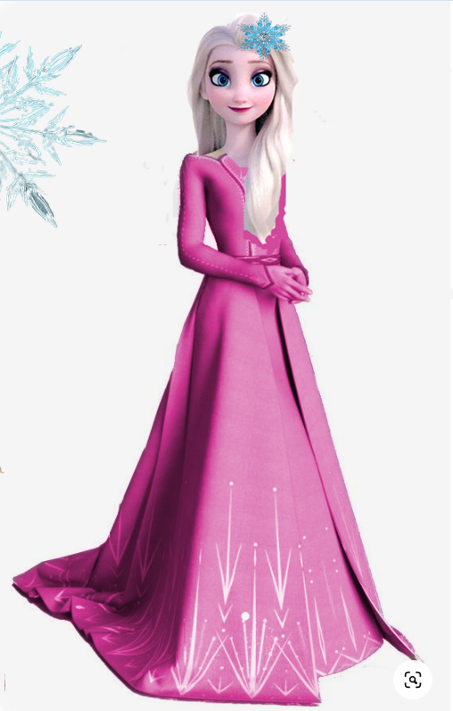elsa

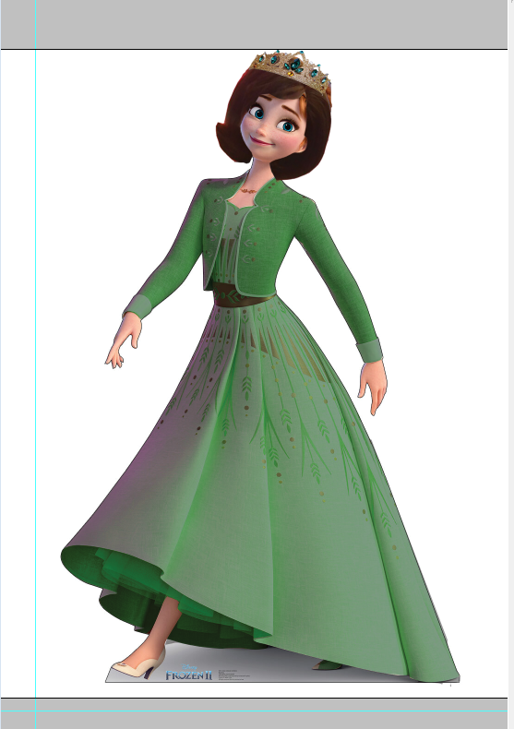anna

olaf

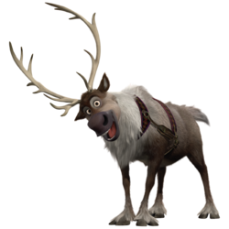swen

How do you plan to make your game engaging?

My game will be made engaging by the obstacles and the special rewards I keep in between. It will also be made engaging by the houses ,in which children have got presents and some have not, so one has to keep an eye on the houses and throw the gift to the right house.